Lab 3 - Routing Protocol

NAME:
CHAU YING JIA
MATRIC NUM.:
A23CS0213 SECTION: 12
INTRODUCTION
This lab looks into the network layer, focusing on subnetting and routing.

TOPOLOGY

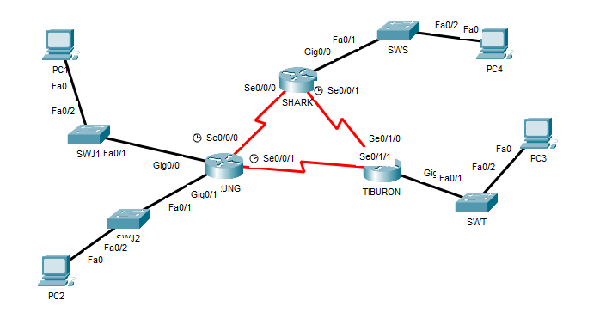

LAB INFORMATION
Here is some basic information for the lab. The network address given is 172.18.110.0/23.
Table 1

Device | Subnetwork | Usable Hosts
JERUNG | LAN1 | 20
 | LAN2 | 30
SHARK | LAN | 60
TIBURON | LAN | 50
Connections | JERUNG-SHARK | 2
 | JERUNG-TIBURON | 2
 | SHARK-TIBURON | 2

Table 2

# | Device  Name | Interface | IP Address | Subnet Mask | Gateway
1 | JERUNG | Se0/0/0 | 172.18.110.193 | 255.255.255.252 | -
2 |  | Se0/0/1 | 172.18.110.197 | 255.255.255.252 | -
3 |  | G0/0 | 172.18.110.129 | 255.255.255.224 | -
4 |  | G0/1 | 172.18.110.161 | 255.255.255.224 | -
5 | TIBURON | Se0/1/1 | 172.18.110.198 | 255.255.255.252 | -
6 |  | Se0/1/0 | 172.18.110.202 | 255.255.255.252 | -
7 |  | G0/0 | 172.18.110.65 | 255.255.255.192 | -
8 | SHARK | Se0/0/0 | 172.18.110.194 | 255.255.255.252 | -
9 |  | Se0/0/1 | 172.18.110.201 | 255.255.255.252 | -
10 |  | G0/0 | 172.18.110.1 | 255.255.255.192 | -
11 | PC1 | - | 172.18.110.158 | 255.255.255.224 | 172.18.110.129
12 | PC2 | - | 172.18.110.190 | 255.255.255.224 | 172.18.110.161
13 | PC3 | - | 172.18.110.126 | 255.255.255.192 | 172.18.110.65
14 | PC4 | - | 172.18.110.62 | 255.255.255.192 | 172.18.110.1

LAB TASKS
Task 1 – IP Addressing
- Given the network address of the organisation and the basic information provided in both Tables 1 and 2. Show your workings here and complete Table 2 with the correct information. PCs will be given the last usable address of the subnetwork.

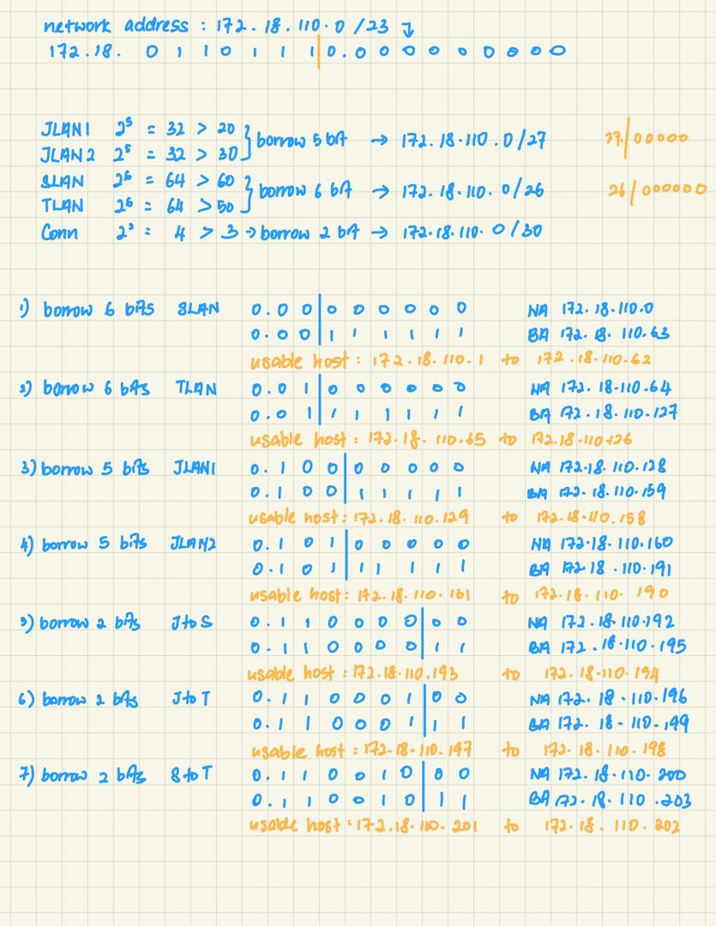
- Using the IP addresses calculated, configure the devices with the appropriate information.

Task 2 – Routing Table
- Paste the current routing table of each router here. There are 2 ways to this – via CLI and via Packet Tracer (PT) tool. Use both ways to show the routing table of all the routers.
  - CLI
    - Click on a router. In the prompt, type show ip route. The routing table of the router will be shown, as shown in Figure A.
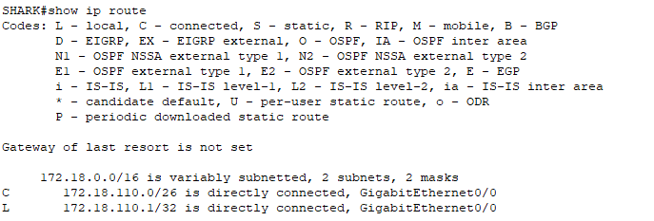
Figure A
JERUNG:
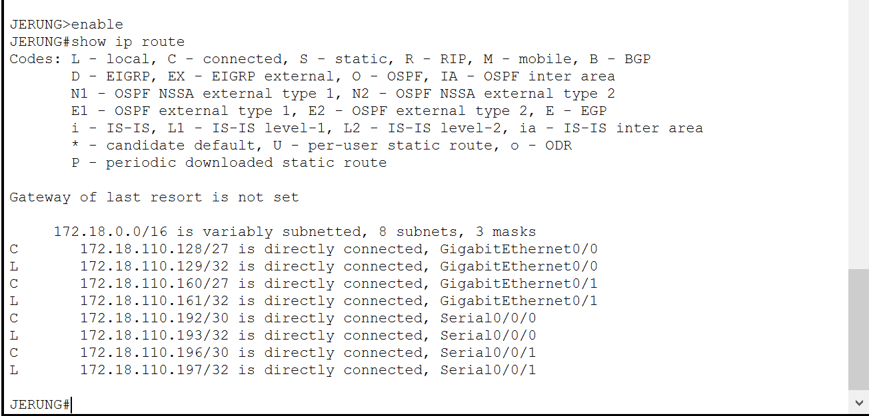

SHARK:
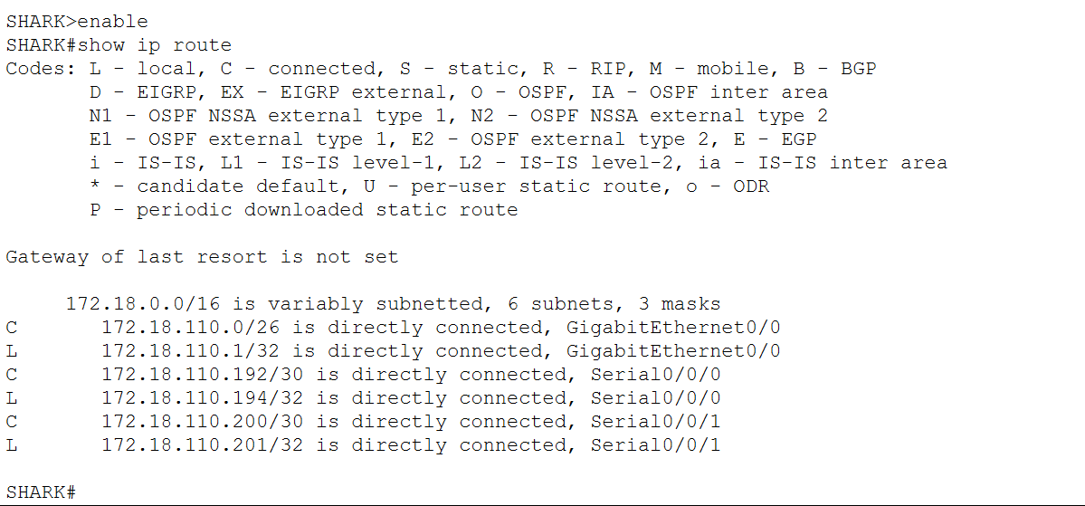

TIBURON:
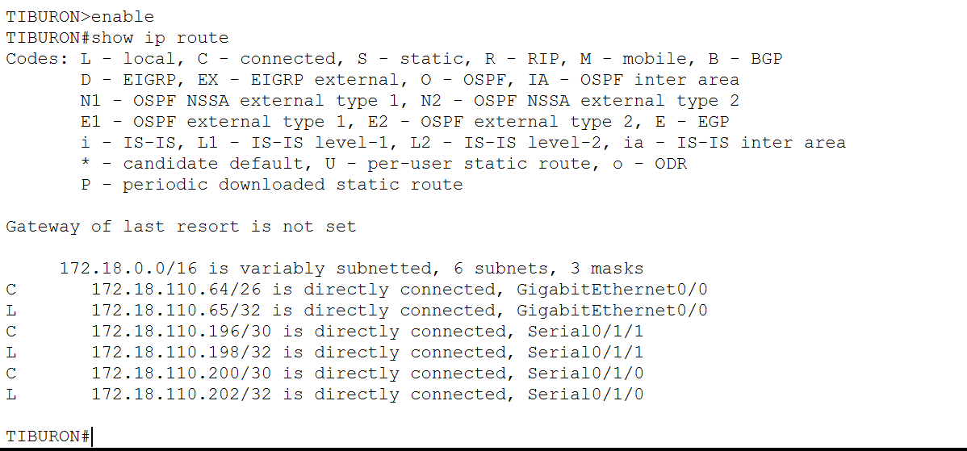

  - PT tool
    - Click on the magnifying glass (shown in Figure B), then click on a router, then choose Routing Table. A sample of the result is shown in Figure C.
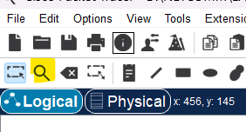
Figure B
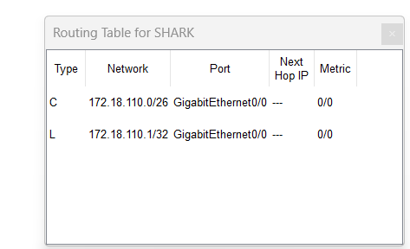
Figure C

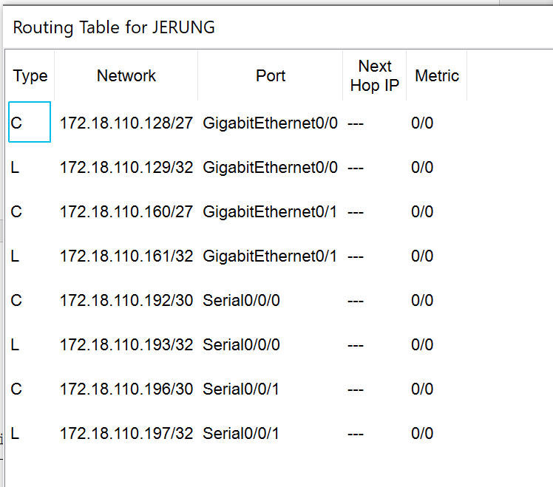
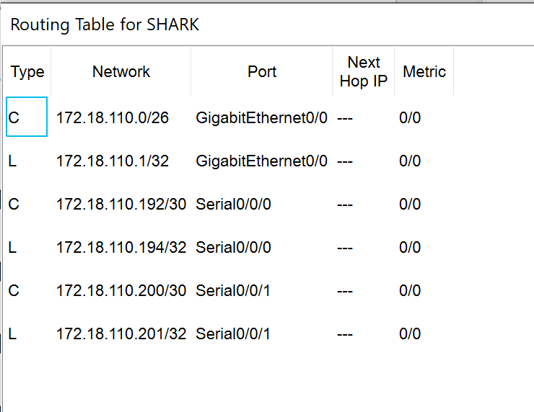
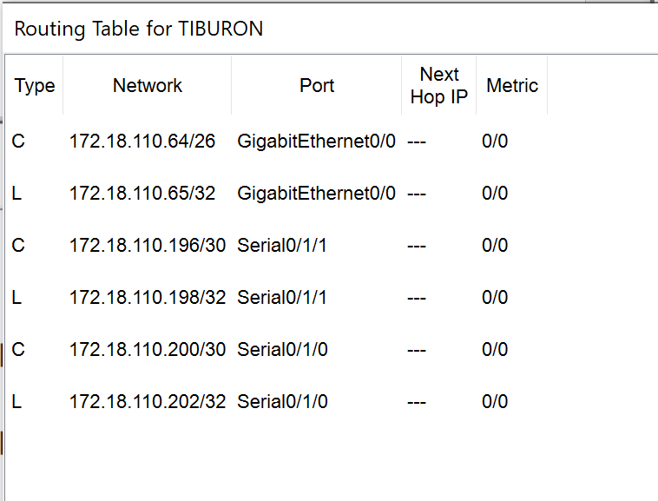

- Try to ping PC2 from PC1, paste the results here.
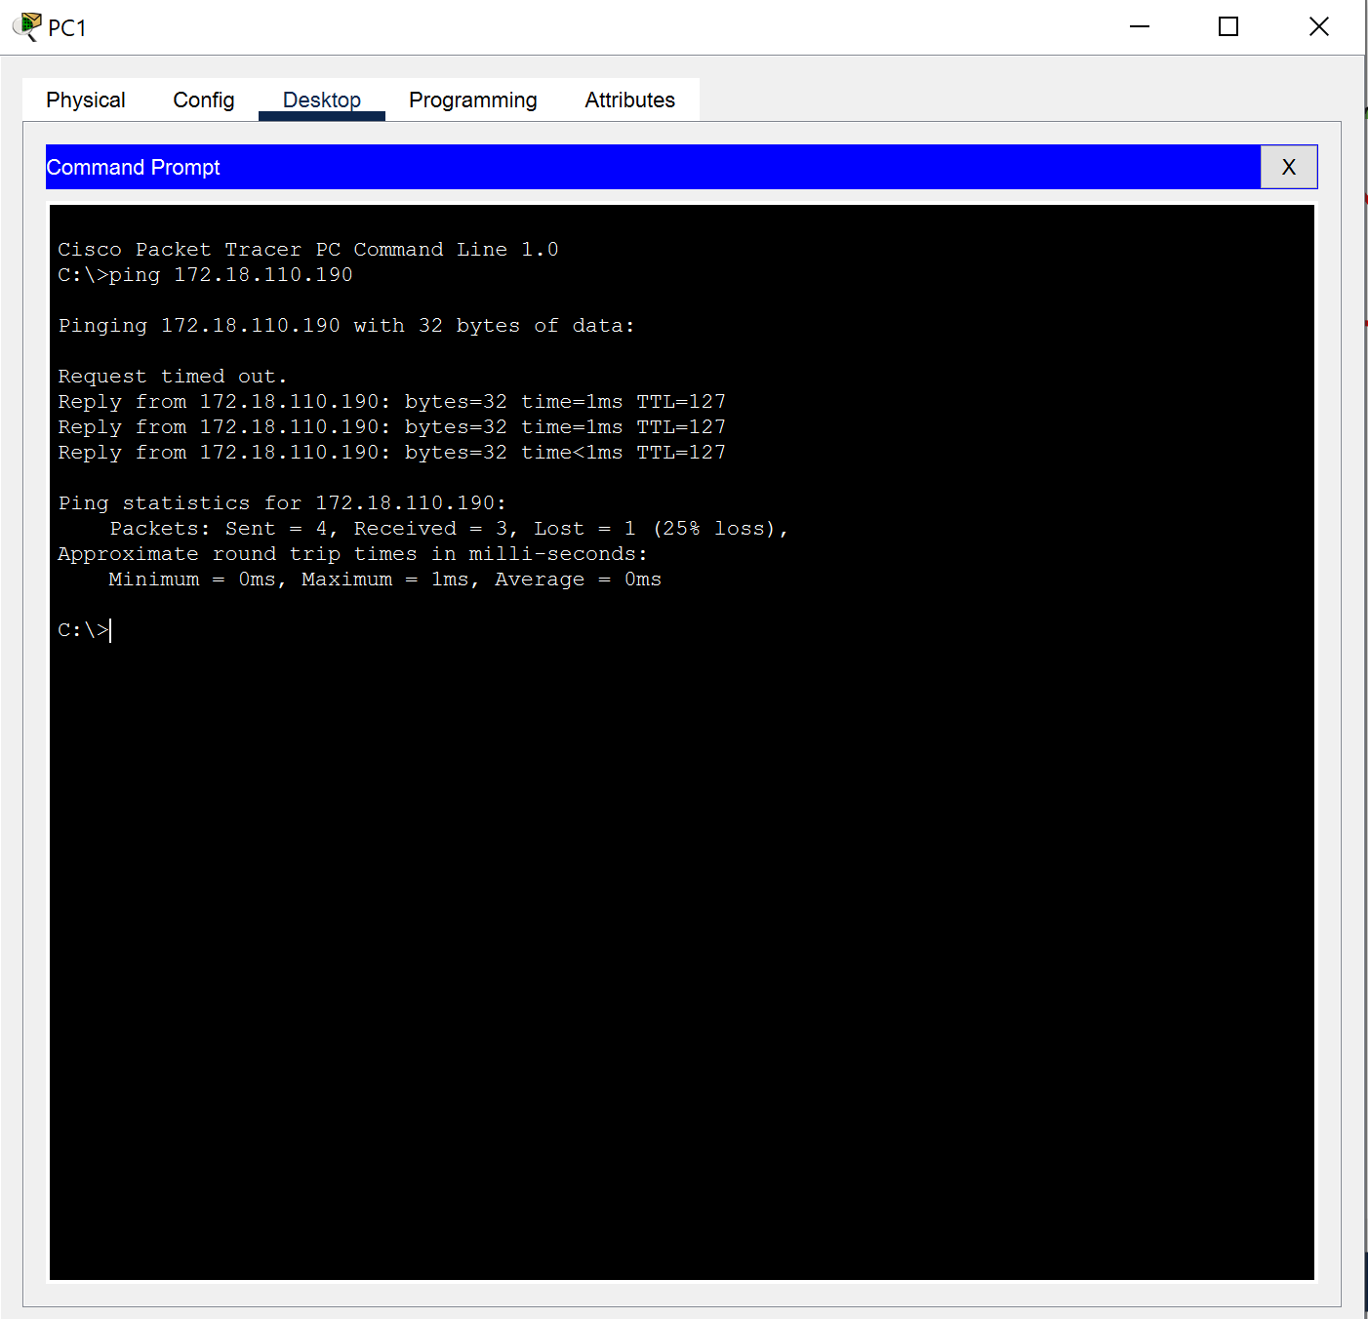
Success

- Try to ping PC4 from PC1, paste the results here.
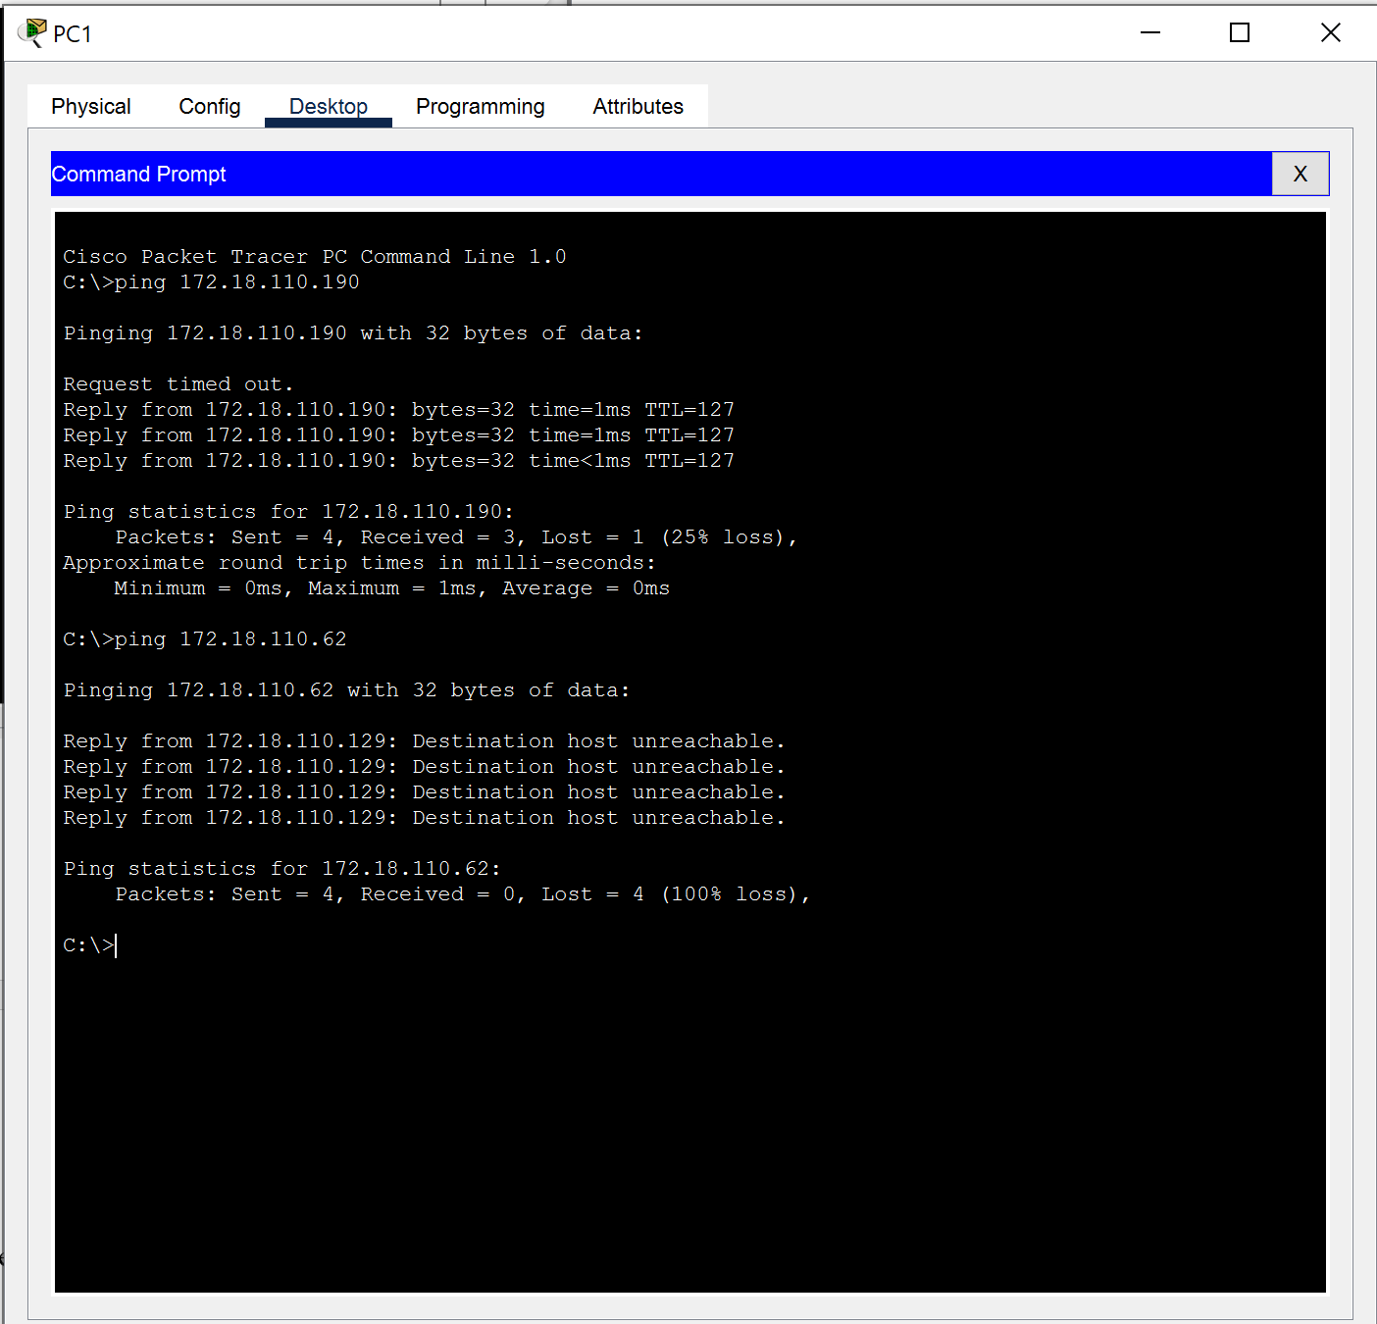
Fail

- Explain the reason(s) behind the results.
For the first ping from PC2 from PC1 successes as they are connected in the same subnet, the connection is working correctly and allow communication.
For the second ping PC4 from PC1 is unsuccessful as both are from different subnet, the connection between them is not properly configured yet.

- What needs to be done to ensure all PCs can ping each other successfully?
The connection between routers must be correctly configured to ensure all network segments are interconnected, enabling a proper routing path for forwarding traffic between the PCs.

Task 2 – Routing Configuration
- Let’s start by opening the routing table (using the PT tool) for TIBURON and JERUNG. This is done to show changes to the routing table as configurations are made.
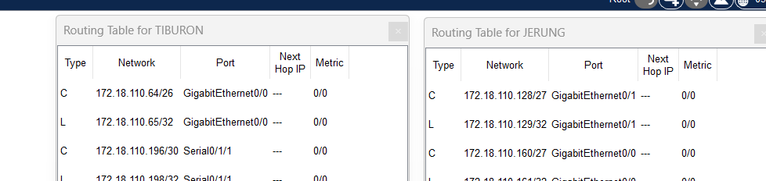
Figure D
- In router JERUNG, configure the RIP routing protocol as shown in Figure E.
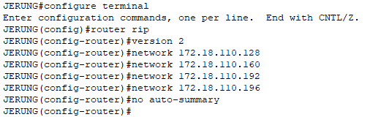
Figure E
  - What can you say about the addresses used in the ‘network’ instructions in Figure E?
The addresses used are all network address(NA) of router JERUNG’s. They act as the router information (self-contained network) of JERUNG.

- Then configure RIP in TIBURON. All are similar except use the network address. Use the instructions as shown below.
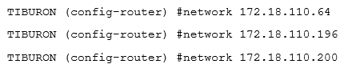

- As you may have seen, there are changes in the routing tables of both TIBURON and JERUNG. Paste a copy of these routing tables here.

TIBURON:
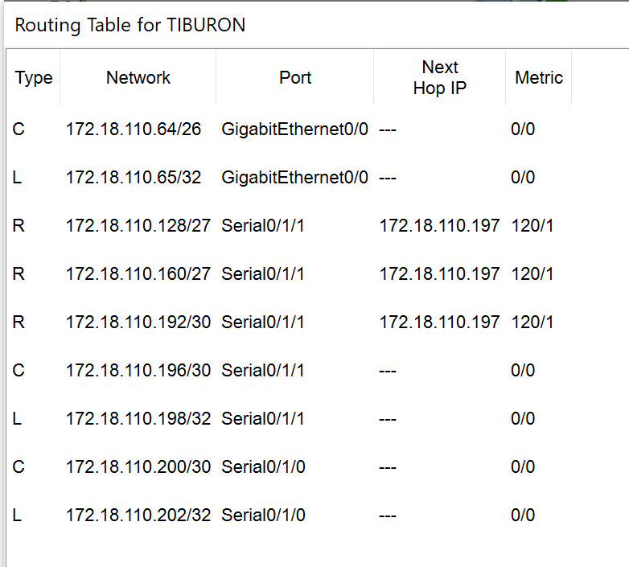

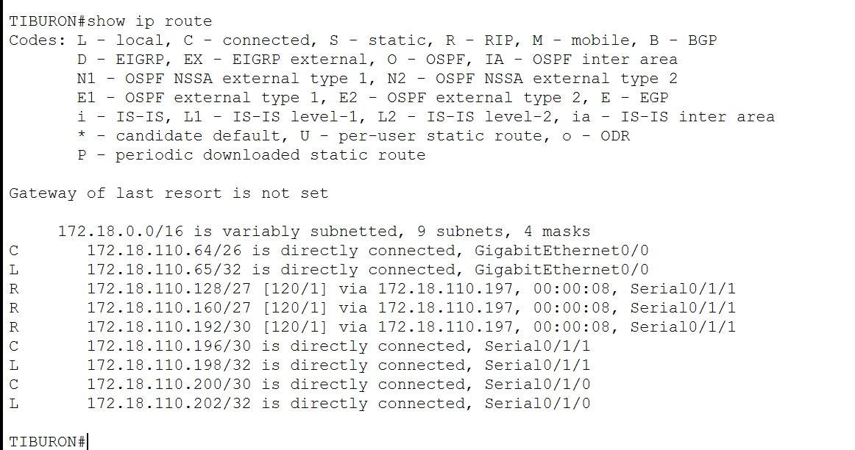

JERUNG:
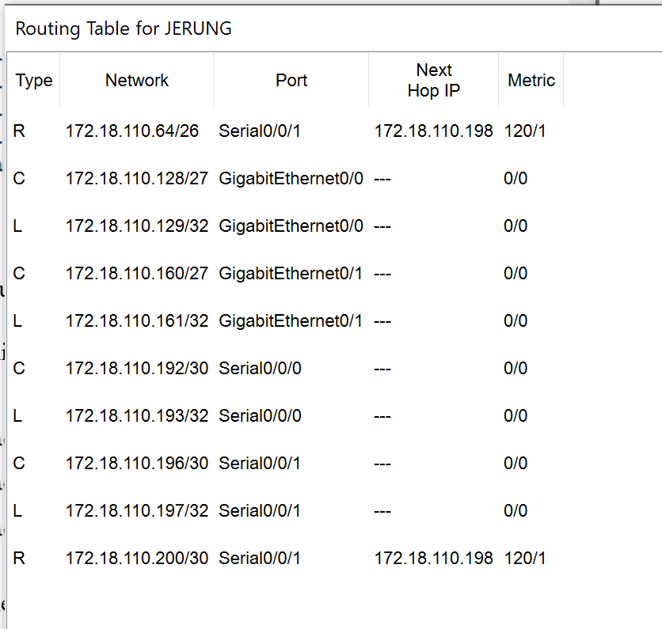

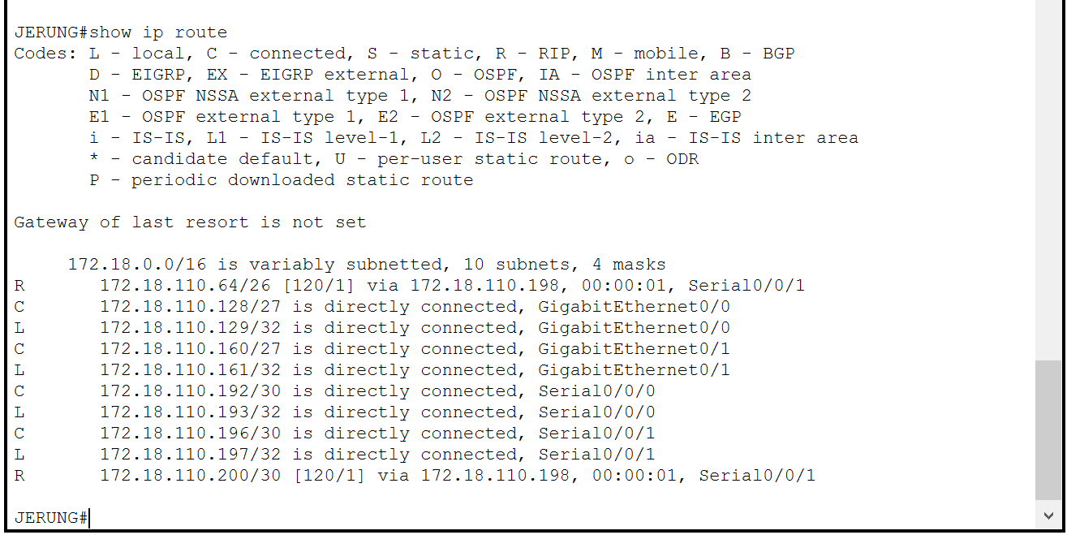

  - What are the changes seen in TIBURON?
A new route generated by the RIP protocol appears in the routing table and is marked with an "R" which stands for RIP.

  - What are the Networks with type R in TIBURON and JERUNG?
The networks with the type "R" in the routing table are those routers which could learned dynamically through the RIP (Routing Information Protocol) without requiring manual configuration for every new or changed network. RIP is used to manage the router information in a self-contained network.

  - Ping PC3 from PC1. Was it successful?
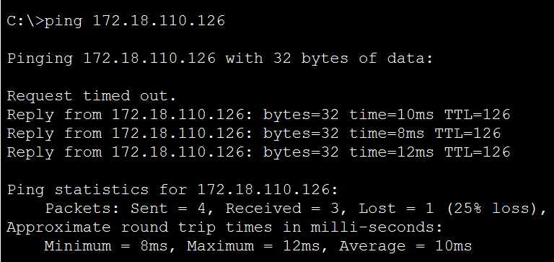
Yes, it was successful.

  - Ping PC4 from PC1. Was it successful?
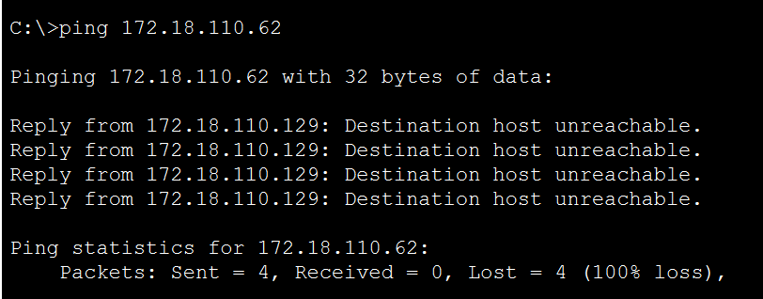
No, it was not successful

  - Explain the reasons for your answer.
The ping from PC1 to PC3 was successful because the network connection between them is correctly configured, and the routes are properly set up to allow communication. The RIP routing protocols on JERUNG (for PC1) and TIBURON (for PC3) have been configured correctly and automatically updated in the routers' routing tables.
The ping from PC1 to PC4 was unsuccessful because the network connection between them is not properly configured, and the route has not yet been set up. Additionally, the RIP routing protocol and routing table on SHARK (for PC4) have not been properly configured.

  - Continue with configuration of RIP in SHARK. Paste your configurations here.
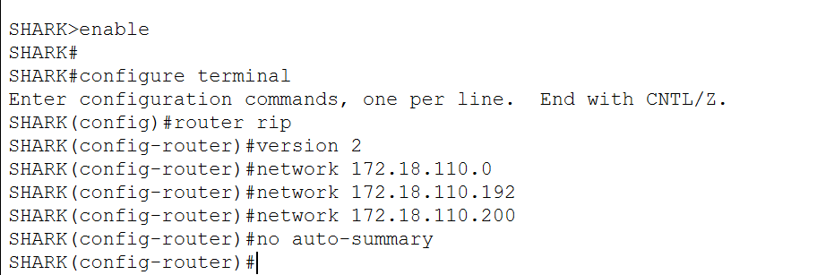
  - Open router SHARK’s routing table and paste here.
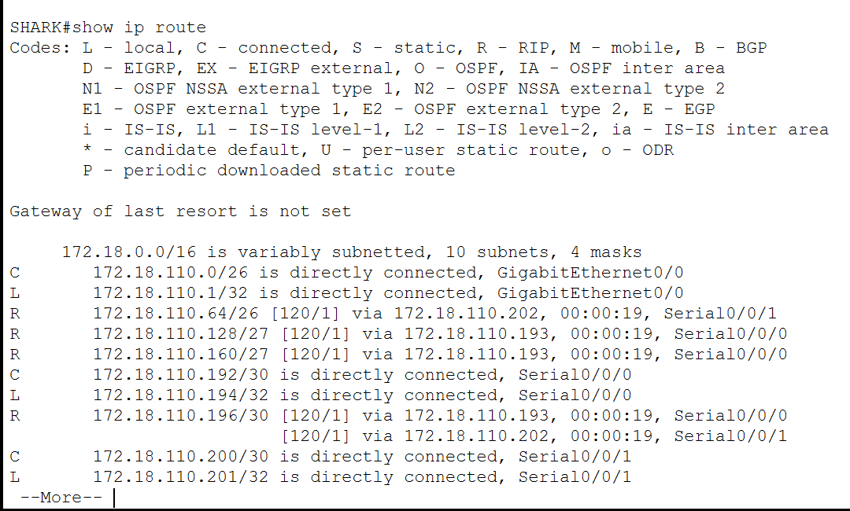

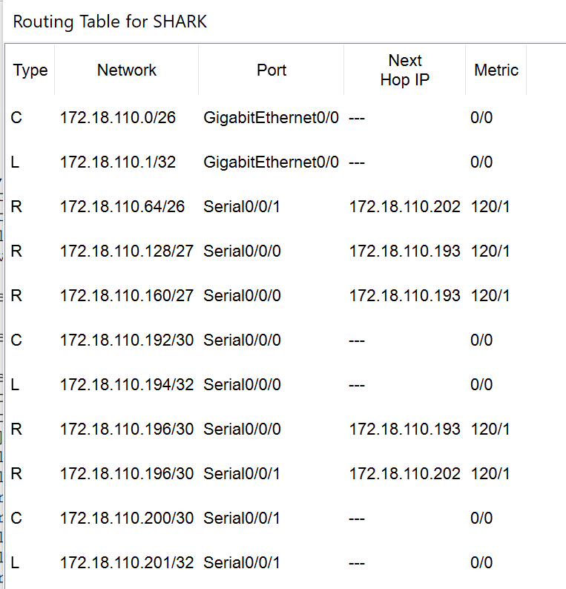
  - Try to ping from PC4 to all other PCs in the topology. *Note: Try to ping at least twice to get best results.
PC | Ping result
1 | 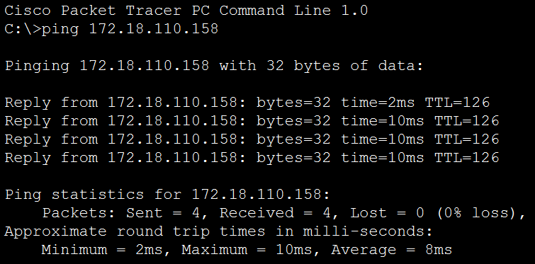  Successful
2 | 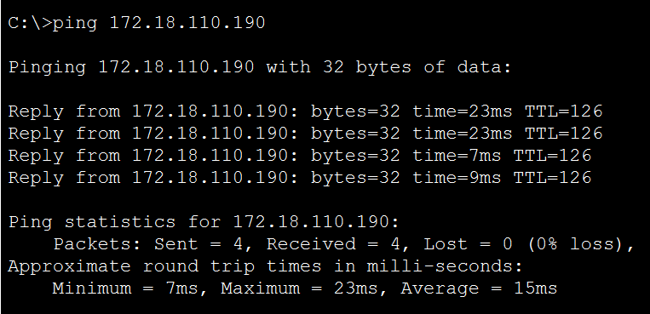  Successful
3 | 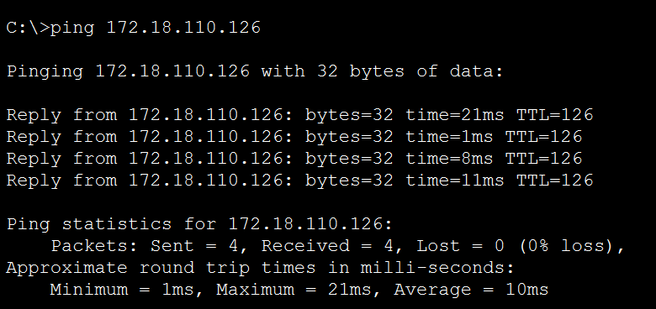  Successful

Task 3 – Routing Update
- Let’s try a little experiment. Change the IP addresses of router TIBURON interface G0/0 to 192.168.1.1/24.
  - This means that the subnet has changed. Find the new Network address of this subnet. Network Address is: 192.168.1.0/24
  - As this change happens, PC3 must also have different IP address, subnet mask and gateway address. What will it be?
PC3 | Info
IP address | 192.168.1.254
Subnet Mask | 255.255.255.0
Gateway Address | 192.168.1.1

  - After this change, can PC4 and PC1 ping PC3?
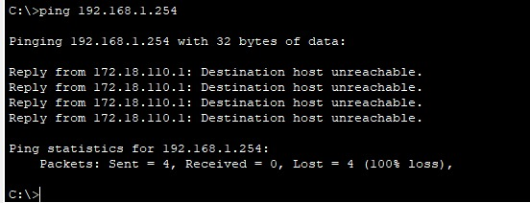
From PC4: Fail

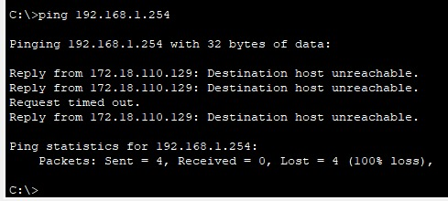
From PC1: Fail
PC4 and PC1 cannot ping PC3 after this change

  - Copy and paste the routing tables for both SHARK and TIBURON here.
Shark:
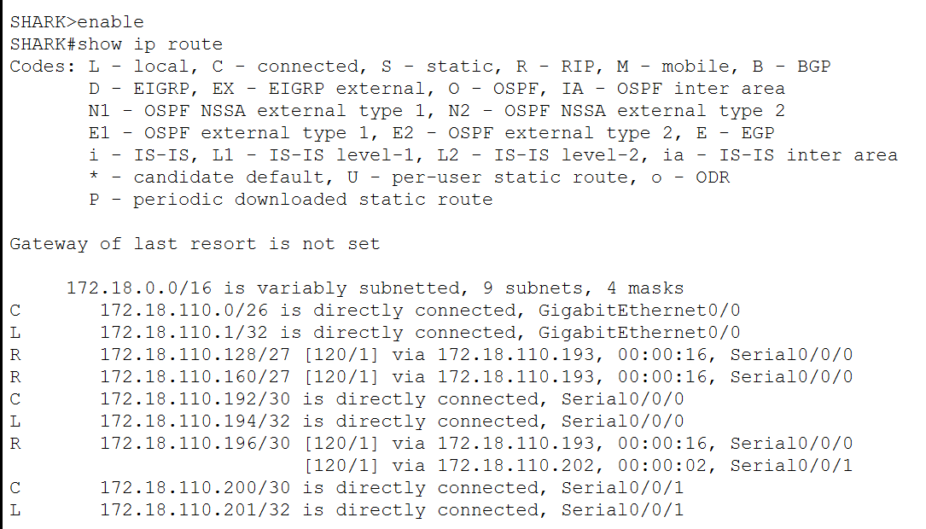

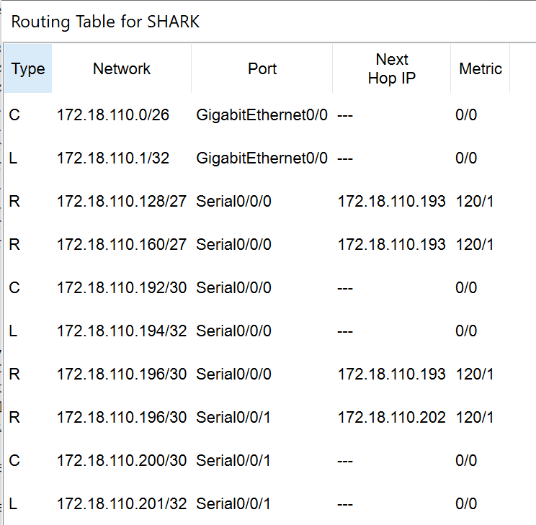

Tiburon:
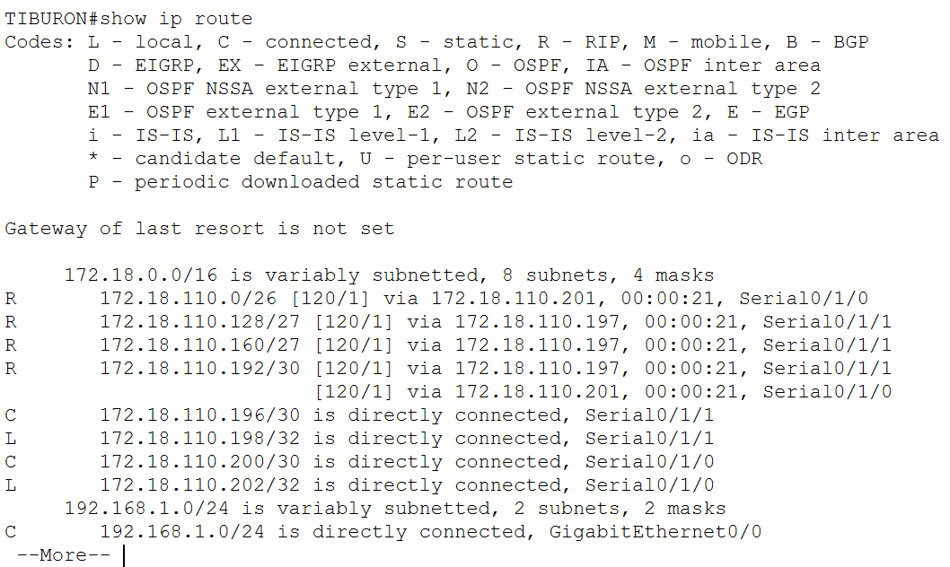

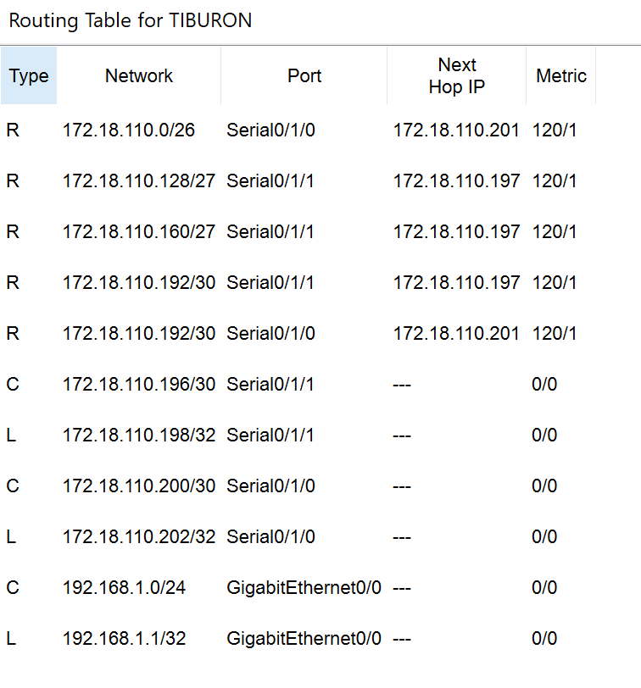

  - Referring to the routing table, explain your findings.
The routing table has not been updated with the new network address of the subnet. As a result, packets destined for PC3 are dropped, causing PC4 and PC1 to fail when attempting to ping PC3 after the IP address change.

  - What is your next move to ensure end-to-end connectivity (i.e. all PCs can ping each other successfully)?
I will update the routing configurations on TIBURON to include the new subnet (192.168.1.0/24) and enable its advertisement through the RIP protocol. This will ensure the subnet could automatically propagated and updated in the routing table of TIBURON, enabling connectivity between all PCs.

  - Show your configurations in TIBURON to ensure end-to-end connectivity.
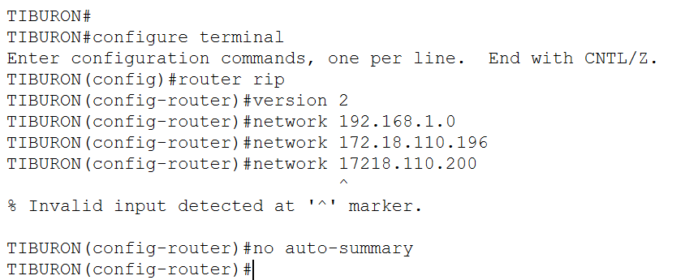

  - To ensure end-to-end connectivity, ping to all the PCs from PC3.
PC | Ping result
1 | 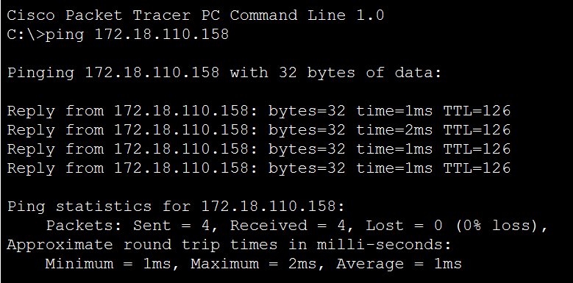  Successful
2 | 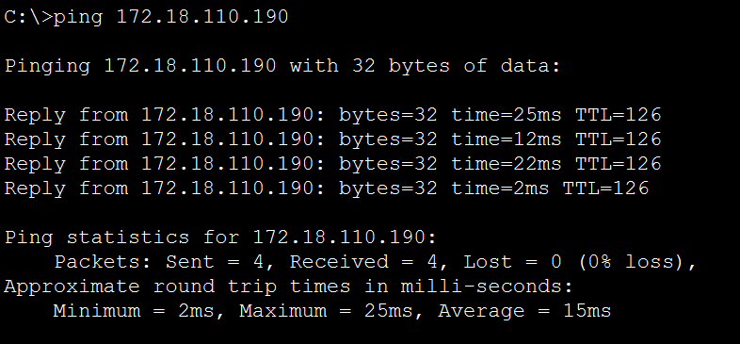  Successful
4 | 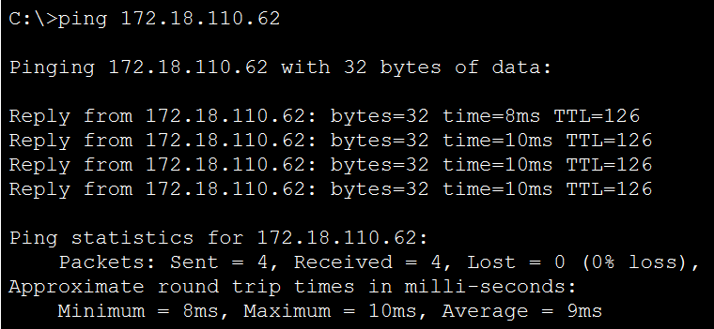  Successful

REFLECTION
What have you learned in this task?
Throughout this task, I have gained a wealth of knowledge. While our studies have primarily focused on lecture notes, I struggled to know how a network professional connects all these elements. Initially, it was quite challenging since I was unsure if I was executing things correctly. In this lab, I learned about routing, networking, and subnetting calculations. Proper subnet calculations are essential for the correct assignment of IP addresses and the effective use of network resources. Any miscalculation could disrupt the entire process, requiring me to start over. Additionally, I discovered how to utilize the RIP protocol for automated configuration and updates of routing tables. I also learned to use the ping command for troubleshooting, helping me to determine if the connection was successful or not. I now know how to identify connectivity issues when they arise. From this lab experience, I understand that configurations like changing IP addresses and subnets impact the overall network behaviour, and I must ensure I update all affected segments before troubleshooting. Last but not least, in this lab I could understood more about the theory and reasons behind all the successfully or unsuccessfully connection between devices.

